Name:
Professor:
Course:
Date:
Energy Systems Analysis and Assessment
Geothermal Hybrid Energy System
Summary
This project is aimed at designing an energy system that will help in the generation of electricity and other industrial purposes like cooling and heating. The project will focus on designing a geothermal energy system that will be sustainable and efficient. The project will offer a detailed description of geothermal hybrid energy system, cover the concepts of this technology, and provide equations showing energy efficiency. The resultant design has an efficiency of 97.5%, implying that it is a sustainable design that is environmentally friendly.
Introduction
One of the main challenges that industries face today is increased greenhouse gas emissions. Increased carbon footprint in the globe has prompted companies and governments to design sustainable energy systems, which in addition to minimizing carbon footprint in the atmosphere, ensure that there is energy sustainability for future generations. Increased greenhouse gas emissions are associated with an increase in global temperatures, which, in turn, has resulted in global warming. Global warming is considered a problem that threatens lifestyles, livelihoods, and the earth's ability to sustain life (U.S. Environmental Protection Agency). Over the decades, the planet has been rapidly warming, as signified by the rising ocean levels, increased atmospheric temperatures, and the presence of catastrophic weather occurrences like heatwaves, storms, and pest invasions. According to NASA, global warming is the long-term heating of the earth's climate system observed between the mid-19th century to the turn of the century because of human activities, notably the burning of fossil fuels. Human activities have increased the volume of carbon emissions trapped in the earth's atmosphere, which acts as a trap for greenhouse gases. As a result of these challenges, this project aims to design an efficient energy system that will mitigate increasing carbon emissions and promote sustainability.
The system designed in this project will rely on geothermal gases as the primary source of fuel. A geothermal energy system developed in this case will be used as an alternative heating and cooling system, which will integrate an electric heat pump and a gas furnace. This system will be developed to react to the changing temperatures by activating heating and cooling as per the user's needs. The course will be built to extract energy using geothermal heat pumps, distributed using a hydronic system. Addressing the challenge of clean energy production is necessary because it will help in the implementation of proper carbon emissions control and provide clean, sustainable energy to current and future generations.
Objectives
- Design a system that provides the community with sustainable energy
- Design a system that addresses the electricity, heating, and cooling needs of the community
- Design an environmentally friendly system, which will provide the community with sustainable energy
System Description
The geothermal energy system that will be designed is, as shown in sketch one below.
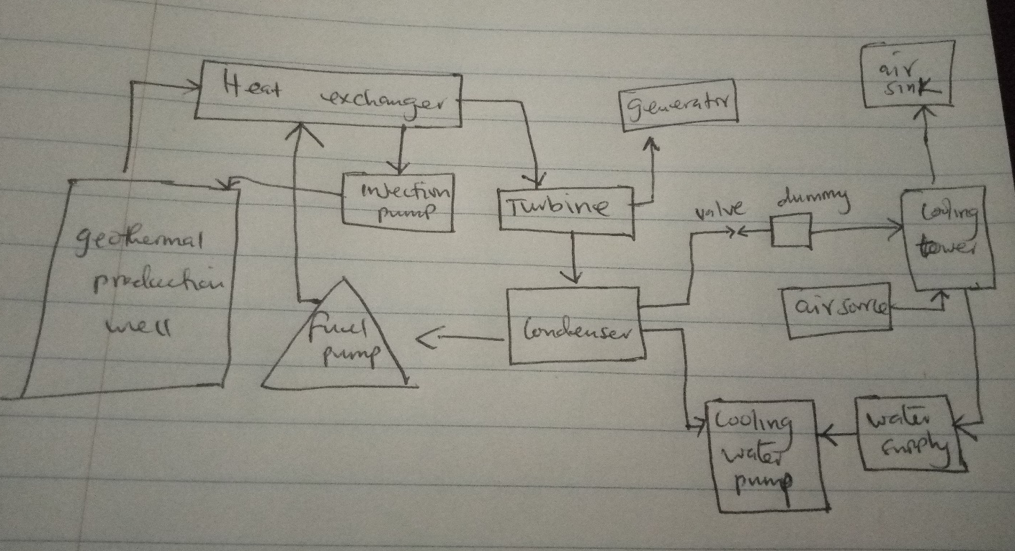
Sketch 1: Design for a geothermal energy system
The design presented in the sketch is designed to produce electricity and address heating and cooling problems. The system's main components include a geothermal production well, heat exchanger, fuel pump, injection pump, turbine, generator, condenser, cooling water pump, water supply, cooling tower, and an air sink. Using pipes, heat is directed into the gas's bores and mixed with the heat released from the heat exchanger. The heated air is then run from the heat exchanger to the turbine, connected to a generator and a condenser. The heated air at this moment is used to produce electricity, which is released in the generator. Water from the cooling tower is used to condense excess heat from the turbine, pumped into the heat exchanger. Excess heated air in the turbine is also sent to the cooling tower through a valve, where it is cooled and used as a condenser in the system.
Analysis
Geothermal energy is one of the cleanest and efficient energy systems that are highly scalable, cuts energy costs by over 50%, and are not dependent on wind or the sun's power for operation. According to Goldstein et al., geothermal energy is the terrestrial heat from rocks, fluids, cavities, and fractures on the earth's surface, which is harnessed for the generation of electricity or direct use, like heating, cooling, and other industrial purposes. This system will be a low energy system, implying that the temperatures harnessed will be lower than 100˚C. This will also be a closed-loop energy system, whereby a closed loop of pipes will be laid in the ground vertically at a depth of 50 to 200 meters. The underground lines will be filled with an antifreeze liquid to collect underground heat from the geothermal generation. The collected heat will then be transferred to a heat exchanger. In the heat exchanger, heated air under pressure is used to run the turbines connected to the generator for electricity generation. The condenser will be collected excess heated air from the turbine, which is then resent back to the heat exchanger through a fuel pump. This energy system will be cooled using water and air, which are located in the cooling tower.
From the geothermal production well, heat will be collected at 25˚C, and after being combusted using oil, the temperature of the heated gases will increase to 995˚C. After the gases' temperatures have been raised and directed to the heat exchanger, the heated gases will run the turbine. The turbine is connected to a condenser cooling system, where excess heated gases will be cooled again to 25˚C. After heated air has been used for electricity generation, the excess will be sent to the condenser, where it can be used as a cooling system and as a source of heat.
The equations of conversion of heat are as shown below.
n = 1 – T_{c}/ T_{h}
The equation above will play an important role, showing the viability of extracting geothermal energy and how it can be used for heating and cooling.
n – efficiency
T_{c} – the lowest temperature
T_{h} – highest temperature
The system will experience heat loss because of the environment.
Thermal efficiency = n= W/ Q_{in}
N_{apc} = 1 -W_{apc} / W_{gross}
W_{apc} – input power
W_{gross} – electrical output
Efficiency of the system is
1 – (25/995) = 0.975
0.975 × 100 = 97.5%.
The assumptions made for this system is that there will be not energy loss in the geothermal production well.

Results and Discussion
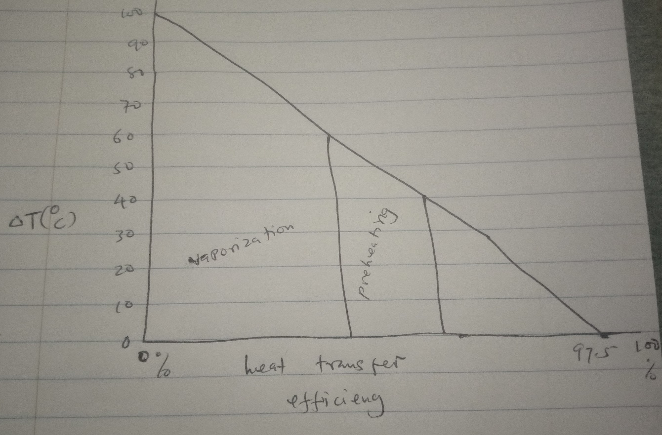
Sketch 2: heat transfer efficiency
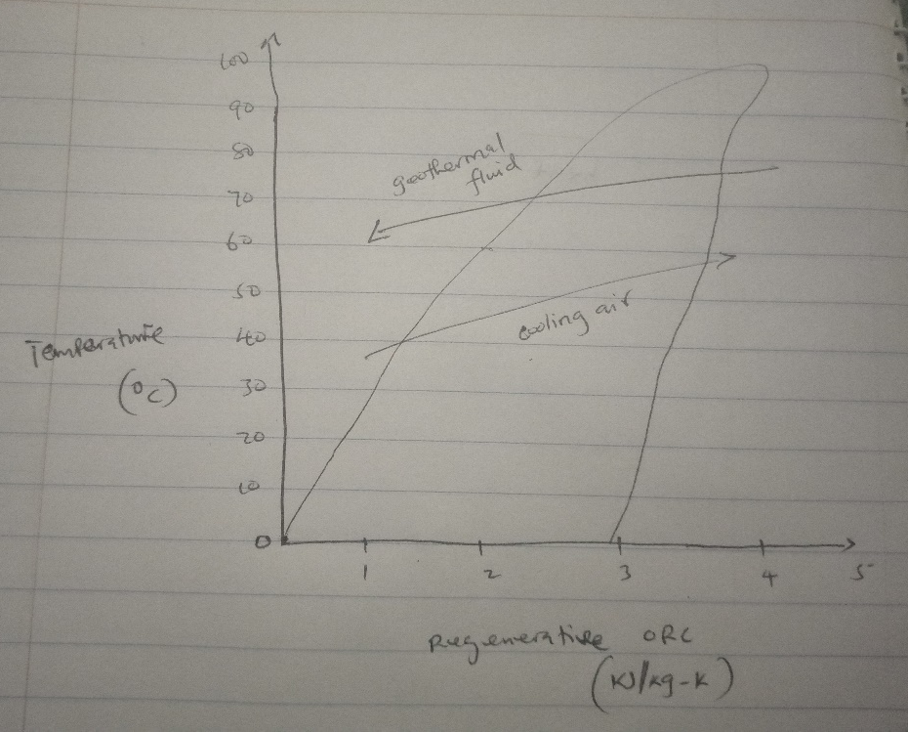
Sketch 3: Regenerative energy changes with changes in temperature
The sketches above show the results of the designed system. Sketch 2 shows the efficiency of heat transferred throughout the system. As calculated in the analysis section above, the efficiency of the system is 97.5%. The efficiency of the system increases as the temperature decreases. In the vaporization area, the efficiency of the system is low. The low efficiency can be associate with the increased loss of heat lost in the form of vapor. In the preheating section, the gases' temperatures are lower, indicating that there is a reduction in heat loss. When the amount of heat lost is decreased, the efficiency of heat transfer increases significantly. After the gases have been preheated, they are slowly cooled in the condenser, making it possible to control heating and cooling. Sketch 3 shows regenerative energy changes with temperature changes. This sketch shows that the cooling air and geothermal fluids act in a counteractive manner. An increase in geothermal fluid temperatures prompts an increase in the cooling air utilized in the system. The regenerative energy released from the system depends on the initial temperatures of the geo fluids, which, in turn, determines the volume of cooling air used.
Conclusions
Sketches 2 and 3 show the functionality of the designed energy system. The system's efficiency is 97.5%, indicating that the system is viable for use as a source of electricity and other industrial processes, including heating and cooling. Findings from the system's design are achieved based on the assumption that there is no energy loss in the geothermal production well. This system's high efficiency shows that it is sustainable and can be used as an alternative energy source.

Works cited
Goldstein, Barry, Hiriart Gerardo, Tester Jeff, Gutierrez-Negrin Luis, Bertani Ruggero, Bromley Christopher, Huenges Ernst, Ragnarsson Arni, Mongilo Michael, Lund John, Raybach Ladislaus, Zui Vladmir, and Muraoka Hirofumi. Geothermal energy, nature, use, and expectations. 10.1007/978-1-4614-5820-3-309
Hameed, Zia, Yousaf Adnan, Ahmad Faiza, Khan Sial, M., and Maqbool Hina. Hybrid system of geothermal power generation using abandoned oil/gas bores assisted by power of solar plates. (, 2019). 246-249. 10.1109/SEGE.2019.8859821
NASA. Overview: Weather, Global Warming, and Climate Change. (, 2020). Available at https://climate.nasa.gov/resources/global-warming-vs-climate-change.amp
The United States Environmental Protection Agency. Inventory of U.S. Greenhouse Gas Emissions and Sinks (2020). Available at https://www.epa.gov/ghgemissions/inventory-us-greenhouse-gas-emissions-and-sinks

